Lesson 6 Day Actions

I've got great news, day actions are so much more fun then taking a walk. Lets make our own special version of restaurant for this example, how about a nice cosplay cafe. First off lets rename the button.

Part A: Renaming Button

If you just want the name changed at the start of game.

function Initialise() {
...
_root.SetButtonState(_root.PlanningDay.RestaurantButton, false, true, "Cospl<font color='#0000FF'>a<font color='#000000'>y Cafe");
}

For SetButtonState you should default the parameters after name except in very rare cases - Cmacleod

The SDK will explain all this pretty well but I'm going to try to do my part.

_root.SetButtonState(name of the button, red slash, other large slash, "name with hot key color change", event number called when pressed, where to look for the event number, Cost);

Basically I recommend you copy and paste from the SDK and modified as you need.

Some important notes. If you modify the button's name mid game you will need to add a copy still in initialize with an if statement, otherwise the buttons change will not be there after you save and load.

Part B:Changing the DoActions

Do actions is the function that is called after pressing the button and asking if you were really sure you wanted to do it. Type is the event number that was set in the previous button press.

function DoActions(type:Number, available:Boolean) : Boolean
{
if ( type == 12) {//Cosplay Cafe formerly restaurant
_root.ServantSpeak("She will work at a cafe dressed in a number of different outfits.");
_root.AddText("\r\r Do you want her to work there?");// go see lesson on text
_root.NoEvent._visible = true;//will explain later
_root.YesEvent._visible = true;//will explain later
return true; //stuff changed
}
return false; //nothing changed do default restaurant
}

Pretty copy and paste here, nothing spectacular.
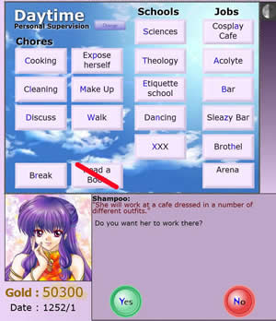

Part 3 Custom Jobs

Lets also while were doing this add a custom job.

function Initialise() {
…
_root.ShowCustomJob();
_root.SetCustomJobDetails("Arena", "battle other slaves in combat");

}

_root.SetCustomJobDetails("Name", "Question Text");
Believe it or not that's it.
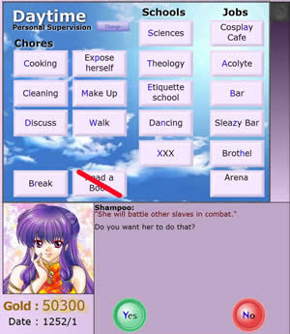

function RunShop() {

}

To access and write your completely original shop just call RunShop.

Part 4: Changing the actual Day

Lots of fun with this one and to tell you the truth your going to have to play with it to get it to work going to give you guys two separate examples and two separate ways to accomplish the same thing.

function ShowJobRestaurant() : Number { //this is the function called first. The only reason were
//calling this is to stop it from putting in generic images
_root.Backgrounds.ShowRestaurant(1); //set the restaurant style back ground
_root.UseGeneric = false; //stops generic images
return 1; //this is changing the pay it multiplies with one being standard. Not used (1.0, 1.1, //1.2, etc.)
}

function AfterJobRestaurant(pay:Number) {
_root.SetText(SlaveName + " some flavor text.\r"); //clear all text
temp = int(Math.random()*2)+1; //new toy random number generator change 2 to
//any number to change the size of the random +1 to stop 0 results
if (temp == 2) { //choose a clip to show based on random number
CosplayClip1._visible = true;
}
else {
CosplayClip2._visible = true;
}
pay = (_root.VarCooking /4) + (_root.VarCleaning /4) + (_root.VarNymphomania /4) + (_root.VarCharisma /4); //creating our own payment scheme
_root.Money(pay);//paying the piper
_root.AddText("\rYou earned: " + pay + "\r"); //relaying pay to the player
}
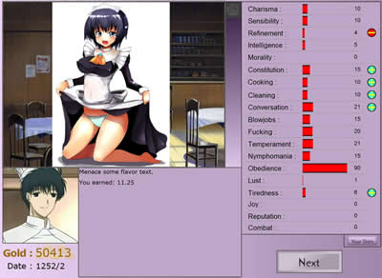

So we are overwriting background picture and generic pictures in the first half. In the second half were putting in the picture, money, and text. Now your probably wondering why we just don't do everything in ShowJobRestraunt. Money will be added automatically with out calling the second part, which is just plain annoying. Note we can add text to ShowJobRestraunt just fine but if we want to delete all text and restart it is necessary to do both functions, to show pay.

Last thing that I want to note is that skills still rise and fall based on the restaurant stat rising and falling. Pull out your _root.Points(0, 0, 0, 0, 0, 0, 0, 0, 0, 0, 0, 0, 0, 0, 0, 0, 0, 0, 0, 0); from the cheat sheet and modify as desired, adding and subtracting to compensate for the ones restaurant puts in automatically.

Example2: Acolyte Overwriting

Normally I feel that one example is fine but for this one I want to show a completely different way to acomplish the same basic thing.

function Initialise() {
...
if (_root.CustomFlag >= 3) //stuff had to happen before we place the button
{
_root.SetButtonState(_root.PlanningDay.AcolyteButton, false, true, "Pre<font color='#0000FF'>a<font color='#000000'>ch", 13, _root.PressDayActButton, 0);
}
}

function DoEventYes() : Boolean //we will explain event handling in the next lesson the main
{ //thing I want to show here is changing a button in an event.
if (_root.NumEvent == 301) {//decide to be a priestess
_root.CustomFlag = 3; //setting custom flag for preach
_root.SetText(SlaveName + " agrees to be a priestess. She will need to preach the word in the streets to become a full priestess." ); //text
EventNun1._visible = true; //picture
_root.NextGeneral._visible = true;//in next lesson
_root.SetButtonState(_root.PlanningDay.AcolyteButton, false, true, "Pre<font color='#0000FF'>a<font color='#000000'>ch", 13, _root.PressDayActButton, 0); //setting button
_root.DoEvent(9999);//next lesson
}
}

function DoActions(type:Number, available:Boolean) : Boolean
{
if (type == 13 && _root.CustomFlag >= 3) {//preach
_root.ServantSpeak("She will go into the town streets and spread the world of the old gods for donations.");
_root.AddText("\r\r Do you want her to work there?");
_root.NoEvent._visible = true;
_root.YesEvent._visible = true;
return true;
}
return false;
}
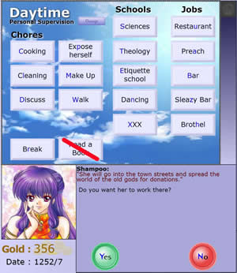

function ShowJobAcolyte() : Number {
if (_root.CustomFlag >= 3) { // if we haven't triggered preach yet don't want to call it
_root.AppendActText = false; //toss old text
_root.SetText(“Flavor Text \r");
temp = int(Math.random()*2)+1; //choose a picture
if (temp == 2) {
EventPreach1._visible = true;
}
else {
EventPreach2._visible = true;
}
_root.Points(1, 0, 0, 1, 1.25, 0, 0, 0, 1, 0, 0, 0, 2, 0, 0, 0, 1, .25, 0); //change stats
return 1; //give normal money
}
else {//dont have preach ability just normal acolyte stuff
AcolyteClip._visible = true; //show pic
return 1;//give normal money
}
return 1;//should never be called just still toss it in there for good programming and maybe later //on will need it.
}

function AfterJobAcoltye(pay:Number) {

return true;
}
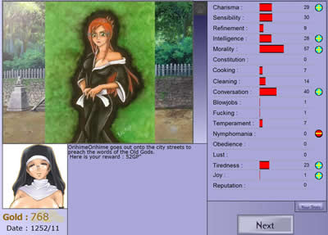

There you go an alternate version to change up how to accomplish the task. I hope that will at least give you something to work with when your trying to your own day actions. Don't expect it to work perfectly from the start. You will have to play with it to get it that way, but in the end this is one of the best ways to add your own flavor to the game.

Next Lesson Events Finally.

